# Description

Addin to pull prices from Bloomberg. More generally there is also functionality to pull data from any website if given an xpath selector

# Addins

There are two addins:

GetBloombergData-AddIn64-packed.xll is the addin for 64-bit excel

GetBloombergData-AddIn-packed.xll is for 32 bit Excel

# Explanation

The functions basically go to a webpage and use xpath selectors to select elements from the webpage

For instance the screenshot below shows a webpage from Amazon. If I right click on the price for this I see that the price is found in a span element with class=”p13n-sc-price”. Now I that I know the URL I can retrieve the Bloomberg price using the following function call in Excel

=getAttribute(“https://www.amazon.com/How-Win-Friends-Influence-People/dp/0671027034/ref=pd_lpo_sbs_14_t_0?_encoding=UTF8&psc=1&refRID=0DHXQX1745RHKNABS68G”, “//span[@class=’p13n-sc-price’]”)

The first argument is the url and the second is an xpath selector

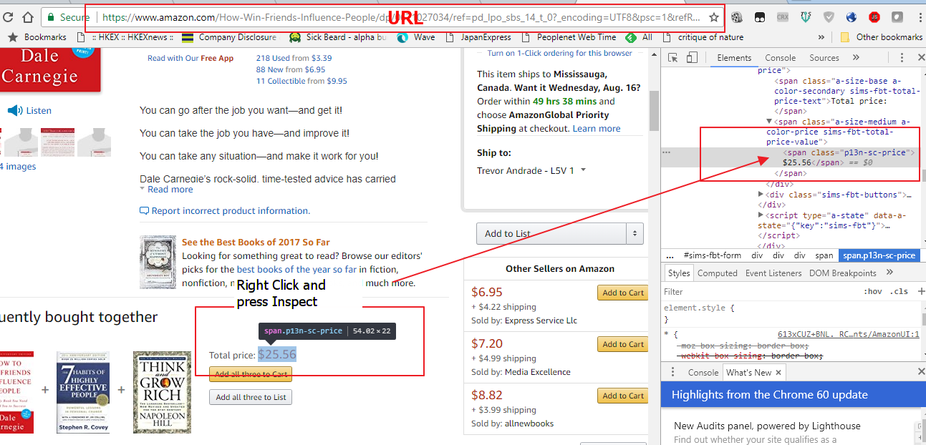

# Functions

getPrice(ticker) – goes to Bloomberg page https://www.bloomberg.com/quote/ticker and grabs the price from that page using the selector //div[@class=’price’]

getName(ticker) – same as get price except that it grabs the name using the selector //h1[@class=’name’]

getBloombergAttribute(ticker, selector) - goes to Bloomberg page https://www.bloomberg.com/quote/ticker and grab text from xpath selector specified in function call

getAttribute(url, selector) – goes to arbitrary url and grabs text from whatever selector is specified in function call argument